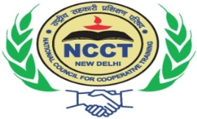 | सहकारी प्रबंध संस्थान  INSTITUTE OF COOPERATIVE MANAGEMENT,  (An Institution of National Council for Cooperative Training, New Delhi, an Autonomous Society Promoted by Ministry of Cooperation, Government of India) | 

DGR COURSES 2024-25

S.No. | Course No. | Course Name | Start Date | End Date | Duration in Weeks
1 | 100-06-2024 | Certificate Course in Small Business / Rural Entrepreneurship | 24-06-2024 | 11-10-2024 | 16
2 | 145-08-2024 | Diploma in Industrial Co-operative Management | 27-08-2024 | 16-11-2024 | 12
3 | 189-10-2024 | Diploma in Industrial Co-operative Management | 21-10-2024 | 10-01-2025 | 16
4 | 234-12-2024 | Certificate Course on General Awareness | 23-12-2024 | 14-03-2025 | 12
5 | 253-01-2025 | Certificate Course on General Awareness | 27-01-2025 | 18-04-2025 | 12

